**Your Task:** Your task is to use the function on any dataset you want or the dataset given

by me in the link above and prepare a report on what results you are getting and how this

function worked.

To

Rishabh Goyal,

From

Pampana Jai Kiran.

Sir, I have successfully completed the task 4.

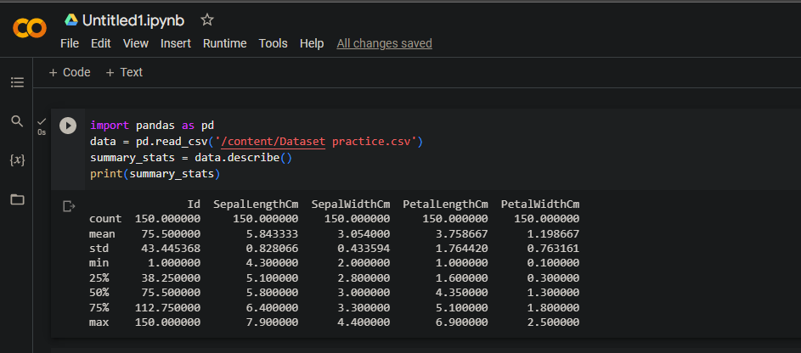

After using Describe function() in the Practice.csv. The generates summary statistics for each numeric column in the dataset.

The statistics include:

Id SepalLengthCm SepalWidthCm PetalLengthCm PetalWidthCm

count 150.000000 150.000000 150.000000 150.000000 150.000000

mean 75.500000 5.843333 3.054000 3.758667 1.198667

std 43.445368 0.828066 0.433594 1.764420 0.763161

min 1.000000 4.300000 2.000000 1.000000 0.100000

25% 38.250000 5.100000 2.800000 1.600000 0.300000

50% 75.500000 5.800000 3.000000 4.350000 1.300000

75% 112.750000 6.400000 3.300000 5.100000 1.800000

max 150.000000 7.900000 4.400000 6.900000 2.500000